Bahria University,

Karachi Campus



COURSE: CEN-221

ARTIFICIAL INTELLIGENCE LAB

TERM: FALL 2024, CLASS: BSE- 6(B)

Submitted By:

AIMAN ZIA SATTI (02-131212-028)

(Name) (Reg. No.)

Submitted To:

Engr Faiz/Engr Hamza

Signed Remarks: Score:_____

INDEX

|  |  |  |  |  |
| --- | --- | --- | --- | --- |
| SNO | DATE | LAB NO | LAB OBJECTIVE | SIGN |
| 01 |  |  |  |  |
| 02 |  |  |  |  |
| 03 |  |  |  |  |
| 04 |  |  |  |  |
| 05 |  |  |  |  |
| 06 |  |  |  |  |
| 07 |  |  |  |  |
| 08 |  |  |  |  |
| 09 |  |  |  |  |
| 10 |  |  |  |  |
| 11 |  |  |  |  |
| 12 |  |  |  |  |
| 13 |  |  |  |  |
| 14 |  |  |  |  |

Bahria University,

Karachi Campus



LAB EXPERIMENT NO.

**_01_**

LIST OF TASKS

|  |  |
| --- | --- |
| TASK NO | OBJECTIVE |
| 1 | **Calculator Program**: Create a simple calculator program that can perform basic arithmetic operations like addition, subtraction, multiplication, and division. |
| 2 | **Guess the Number Game**: Write a program that generates a random number and asks the user to guess it. Provide hints such as "too high" or "too low" until the user guesses the correct number. |
| 3 | **Palindrome Checker**: Write a program that checks if a given string is a palindrome (reads the same forwards and backwards). |
| 4 | **Word Counter**: Create a program that counts the frequency of words in a given text file or input string. |
| 5 | **Fizz Buzz**: Write a program that prints the numbers from 1 to 100. But for multiples of three, print "Fizz" instead of the number, and for the multiples of five, print "Buzz". For numbers that are multiples of both three and five, print "Fizz Buzz". |
| 6 | **Temperature Converter**: Create a program that converts temperatures between Celsius and Fahrenheit. |
| 7 | **Hangman Game**: Implement the classic game of Hangman where the user has to guess a word by suggesting letters within a certain number of attempts. |
| 8 | File Manipulation: Write a program that reads data from a text file, performs some operation (e.g., sorting, filtering), and writes the result to another file. |

Submitted On:

**Date: _____17/02/2024_____**

**Calculator Program:**

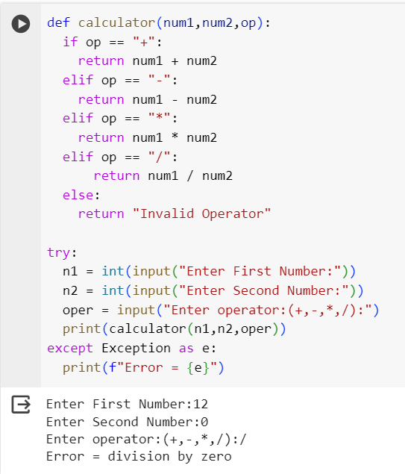

**Guess the Number Game**:

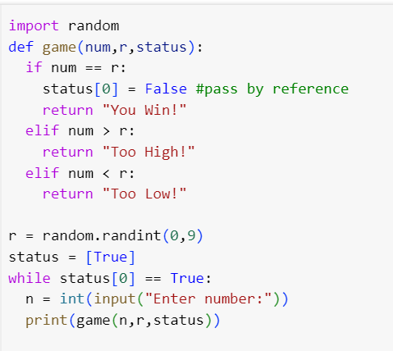

**Palindrome Checker**

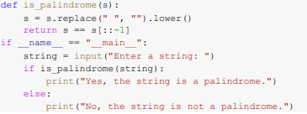

1. **Word Counter**: Create a program that counts the frequency of words in a given text file or input string.

**Fizz Buzz**:

**Temperature Converter**:

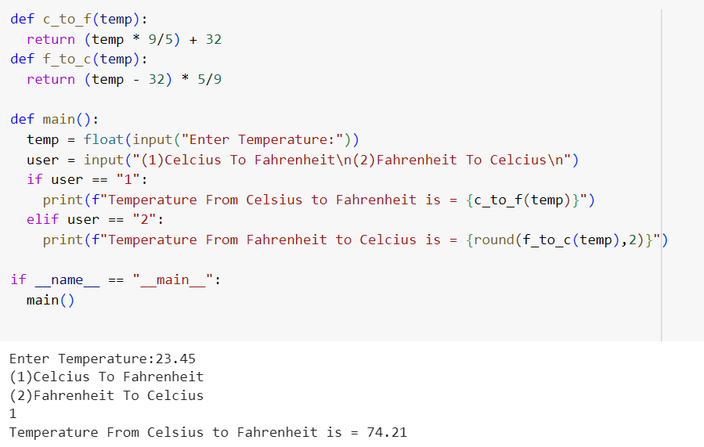

**Hangman Game**

import random

def choose_word():

    words = ["apple", "banana", "orange", "grape", "pear", "peach", "kiwi", "melon"]

    return random.choice(words)

def display_word(word, guessed_letters):

    displayed_word = ""

    for letter in word:

        if letter in guessed_letters:

            displayed_word += letter + " "

        else:

            displayed_word += "_ "

    return displayed_word.strip()

def hangman():

    print("Welcome to Hangman!")

    print("Try to guess the word within 6 attempts.")

    word = choose_word()

    guessed_letters = []

    attempts = 6

    while attempts > 0:

        print("\nGuessed Letters:", guessed_letters)

        print(display_word(word, guessed_letters))

        guess = input("Enter a letter: ").lower()

        if len(guess) != 1 or not guess.isalpha():

            print("Please enter a single letter.")

            continue

        if guess in guessed_letters:

            print("You already guessed that letter. Try again!")

            continue

        guessed_letters.append(guess)

        if guess in word:

            print("Correct!")

            if all(letter in guessed_letters for letter in word):

                print("\nCongratulations! You guessed the word:", word)

                break

        else:

            print("Incorrect!")

            attempts -= 1

            print("Attempts left:", attempts)

    if attempts == 0:

        print("\nSorry, you're out of attempts! The word was:", word)

if __name__ == "__main__":

    hangman()



